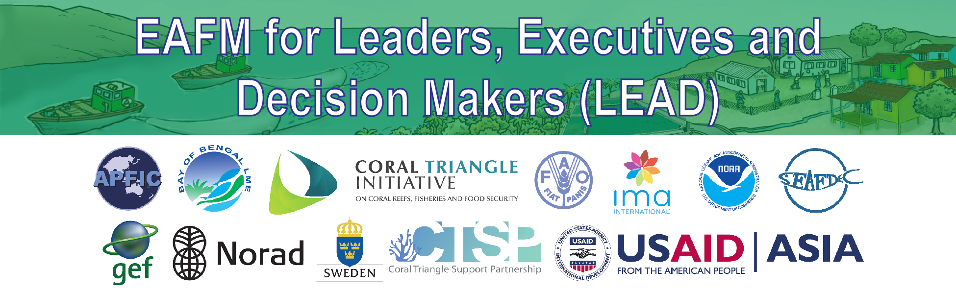
A6: Conversations
How is EAFM different from MSP, CRM, ICZM/ICM and conventional and/or existing fisheries management?
PURPOSE
To prepare facilitators to be able to answer why EAFM differs from some other existing management approaches.
MSP = Marine spatial planning
CRM = Coastal resource management
ICM = Integrated coastal management
ICZM = Integrated coastal zone management

HOW TO USE THIS DOCUMENT
The facilitators should familiarize themselves with the following questions and answers. Definitions of the approaches are at Annex 1.
BACKGROUND
Because many of the existing approaches are based on the “ecosystem approach” concept but were developed in parallel by different user groups with certain management interests, they share many of the same principles and have many commonalities and yet the management focus or coverage can be different. The main differences relate primarily to the target for management (e.g. coastal resources vs. fisheries). From an EAFM perspective, some can be considered as management tools (e.g. MSP and MPA). EAFM is an approach developed specifically for fisheries and will complement may of the other approaches, especially in addressing fisheries resource and fisheries governance issues such as overcapacity, overfishing, IUU fishing and use of destructive gears in a multi-user, multi-sectoral context.

Q & A
Q. How is EAFM different from conventional and/or existing fisheries management i.e. what the fishery agency in your country/province/district is doing now?
A. EAFM moves away from a management system that focuses mainly on the sustainable harvest of target species to a consideration of the major components in an ecosystem and their interactions, as well as the social and economic benefits that can be derived from sustainable management. EAFM recognizes that fish and fisheries are part of a broader ecosystem that includes the habitats where fish live as well as the people who benefit from harvesting, trading and eating fish. There are also other users of the ecosystem and EAFM works to balance the multiple objectives that can impact the ecosystem and/or be impacted by how the system is managed.

Conventional fisheries management often deals with a limited set of threats and issues and often the cause of the problem is not addressed. Decision making is often guided by target species stock assessment, a process not well suited to multi-species, multi-gear fisheries and not factoring in influences from other users and sectors.

Existing fisheries management may be conventional fisheries management (depending on the country or area) or may have adopted some aspects of EAFM, but still also have some aspects of conventional management.
Q. What is the difference between EAFM and ICZM/ICM and CRM?
A. Integrated coastal zone management (ICZM), integrated coastal management (ICM), coastal resource management (CRM) and EAFM all apply the basic principles of an ecosystem approach. While ICZM and CRM use the ecosystem approach to manage land, water, and living resources in coastal areas and promote conservation and sustainable use in an equitable way, EAFM focuses on the fisheries component (including coastal and off-shore waters). Often the fisheries management units go beyond the coastal areas to cover part of the ocean and high seas.
Q. How are MPAs related to EAFM?
A. Marine protected areas or MPAs are clearly defined areas that are afforded greater protection than the surrounding waters for biodiversity conservation or fisheries management purposes. They may include fish sanctuaries or refuges, locally managed marine areas, and no-take areas. From an EAFM perspective, MPAs are an important tool for managing fisheries, but do not equate to EAFM as they cannot address all issues/elements that EAFM includes. Some key elements of fisheries management which MPAs do not usually address include control of fishing capacity, management of an area beyond the boundary of the MPA; and impacts of other uses on fisheries and/or the marine ecosystem.
Q: Is Marine Spatial Planning (MSP) the same as EAFM (or how are they linked)?
A: EAFM and MSP complement each other. EAFM is a process to balance ecological well-being with human well-being through good governance in a fisheries context. To achieve this goal, many tools, processes and approaches, including MSP, can be used. MSP is a public process of analyzing and allocating the spatial and temporal distribution of human activities in coastal and marine areas to achieve ecological, economic and social objectives that are usually specified through a political process (UNESCO, 2009). The term covers both (i) a plan for users; and (ii) implementation tools – e.g. zonation that includes MPAs. MSP can be thought of as a management action for achieving EA objectives in fisheries and taking multiple sectors into consideration.
EAFM complements other approaches
All approaches are encompassed under the ecosystem approach (EA/EBM) (see diagram below). EAFM can incorporates conventional fisheries management and overlaps with co-management, ICZM and MSP.
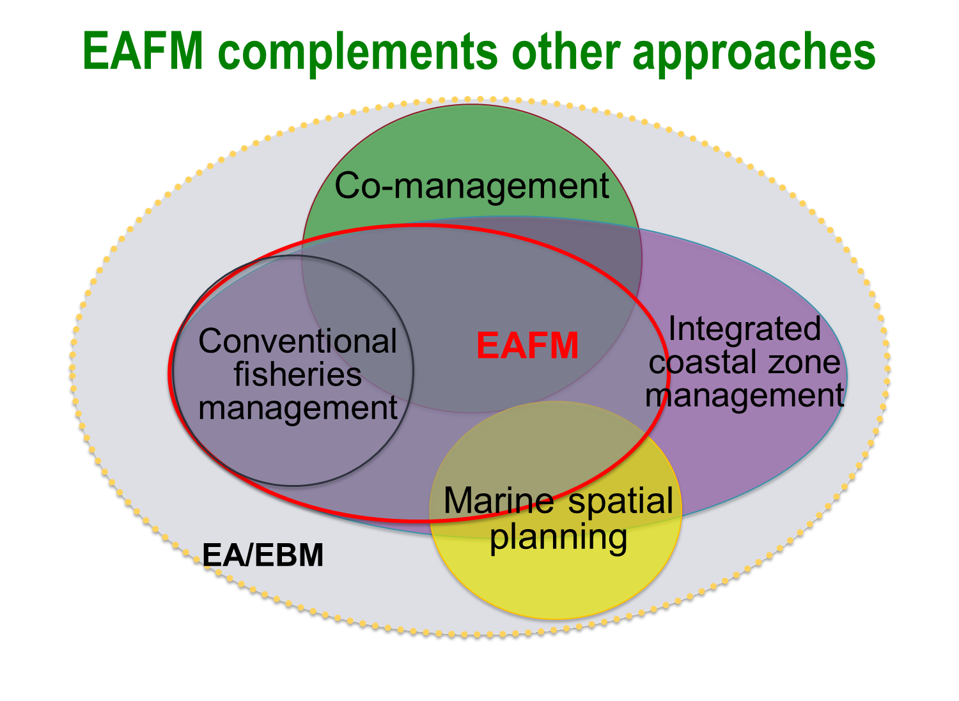

Table: Summary of differences among EAFM/CRM and ICM in the Philippines
 | Management Approaches (may overlap)
 | EAFM | CRM | ICM
Ecosystem approach | Yes | Yes | Yes
Primary resource focus | Fisheries, multi-species | All coastal resources | All of the coastal zone
Primary area focus (spatial scale) | fishing ground, stock distribution range, stock habitats, that may include municipal, national, and international waters | coastal zone, may include associated watersheds, river basins | coastal zone, including associated watersheds, river basins
Governance scale | single or multiple LGUs with jurisdiction covering the fishing ground, distribution range or habitats; complementary jurisdiction of BFAR | generally single LGU, but may be integrated across contiguous LGUs | necessarily multi-LGU, multi-agency, ridge-to-reef because of the scale and complexity of the impacts of coastal activities.
Primary management focus | Sustainability of fisheries, fish habitats, equitable distribution of benefits from fisheries | Sustainable use of all coastal resources, use conflicts among various users of coastal zone (generally users directly dependent on coastal resources) | Conflict management among various users in the coastal zone; minimize adverse impacts of users of coastal zone on the environment.
Relevant legal basis (PH) | Fisheries Code (in RA 10654) | Local Government Code (RA 7160) | ICM (EO 533)
Primary agency responsible | BFAR, LGU (for the most part, issues can be addressed by lead agency, but consults and coordinates with other agencies) | LGU (consults and coordinates with other agencies) | DENR, LGU  Inter-agency coordination and collaboration critical since issues cannot be addressed by single agency.
Co-management arrangements | Yes | Yes | Yes
Zoning/ spatial planning as a tool for management | Yes | Yes | Yes

Annex 1: Definitions
Co-management
Partnership arrangements between key stakeholders (often including government) to share the responsibility and authority for the management of the fisheries and coastal resources, with various degrees of power sharing. Co-management is a fundamental principle of EAFM in that it encourages stakeholder participation, both in planning and implementation.

Conventional and/or existing fisheries management:
Fisheries management is a process designed to improve the benefits that society receives from harvesting fisheries resources. The main aim is to ensure the continued productivity of the target species (and sometimes the associated by-catch) through control of fishing effort, gear, and the total catch of target species. Conventional fisheries management, especially as was applied in temperate countries, does not consider the ecosystem as a whole, nor does it consider other factors, including competing objectives among different users and sectors, that may impact the ecosystem that the fish need to survive and thrive. It also does not consider impacts management (or lack thereof) may have on key user groups.

Ecosystem Approach (EA): A strategy for the integrated management of land, water and living resources that promotes conservation and sustainable use in an equitable way (CBD, 2000). Often used interchangeably with ecosystem-based management.

Ecosystem approach to fisheries management (EAFM): EAFM is a more holistic approach to management that represents a move away from fisheries management systems that focus only on the sustainable harvest of target species, towards systems and decision-making processes that balance ecological well-being with human and societal well-being, within improved governance frameworks, in order to achieve sustainable development. It addresses the multiple needs and desires of societies, without jeopardizing the options for future generations to benefit from the full range of goods and services provided by marine ecosystems (Garcia et al., 2003; Food and Agriculture Organization 2003, 2011).

Integrated coastal zone management (ICZM)/ Integrated Coastal Management (ICM):
An ecosystem approach to managing a coastal area that involves a systematic process for managing competing issues in marine and coastal areas, including diverse and multiple uses of natural resources. Under ICM, decisions are taken for the sustainable use, development and protection of coastal and marine areas and resources.

Marine protected areas (MPA):
A clearly defined area managed and protected (usually by restricting human activities) to achieve conservation of nature, with associated ecosystem services and cultural values. This can be an important tool to address some of the threats and issues identified under EAFM.

Marine spatial planning (MSP):
Planning that delineates user access based on the spatial and temporal distribution of human activities. Sometimes referred to as coastal and marine spatial planning (CMSP). This can be an important tool to address some of the threats and issues identified under EAFM through zoning.

